Ilan Weinschelbaum

Assignment #1

Ex1) 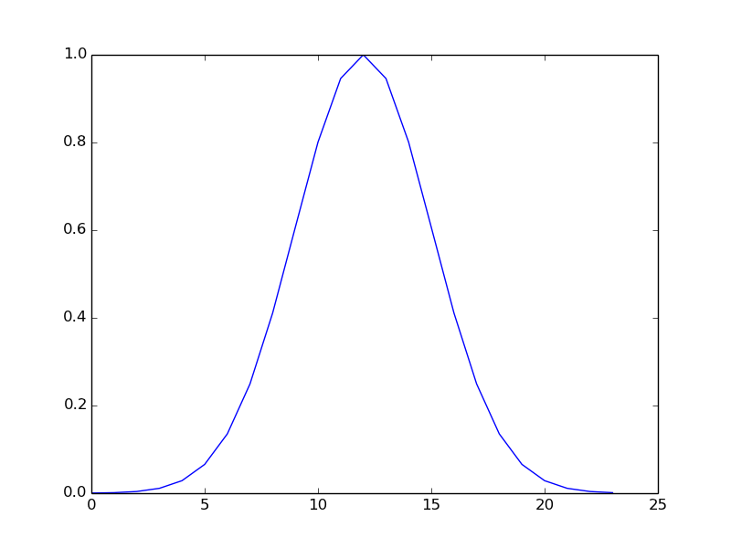

Ex2) 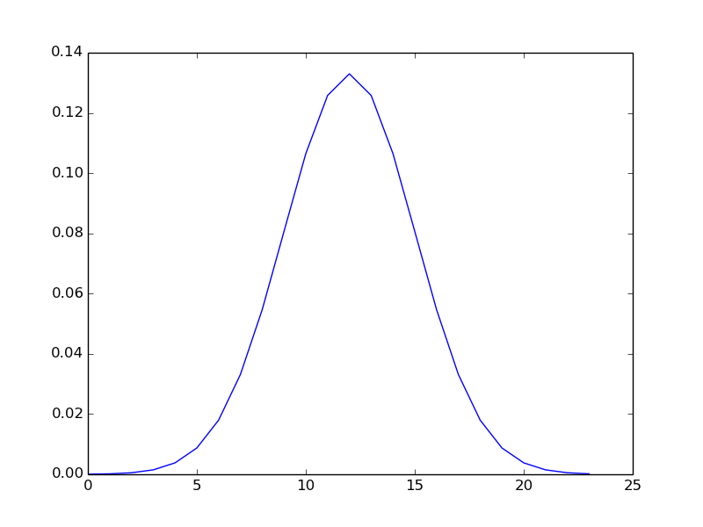

Ex3) 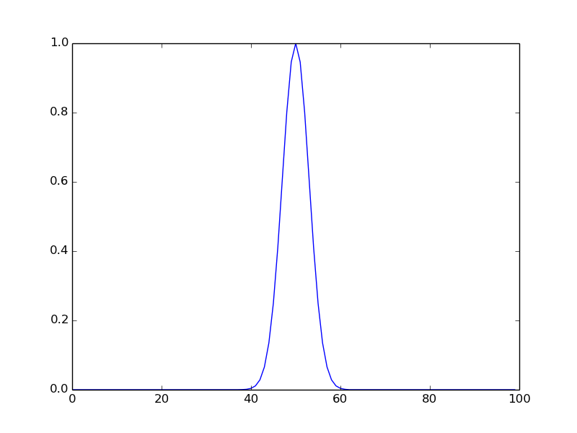

Ex4) sigma = 3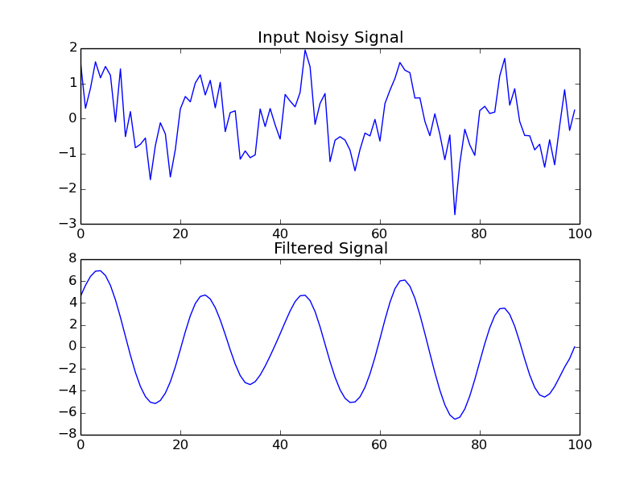

Sigma = 1

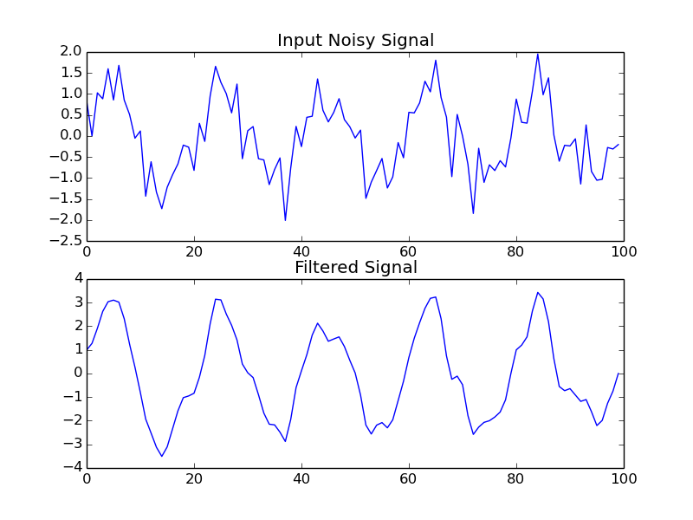

Sigma = 10

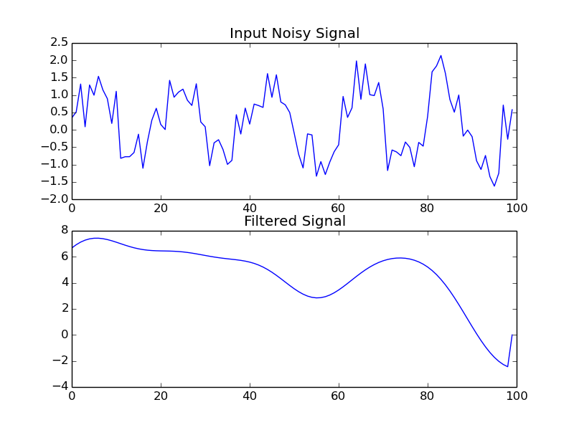

It seems that with higher values of sigma, the curve becomes smoother with lower frequency. This lower frequency makes sense since using a greater standard deviation makes signals less noticeable (they are fewer standard deviations away from the mean). The smoothness also makes sense because different signals are also fewer standard deviations away from each other. PS: the code given in #4 uses sigma=3.